**Worksheet – 3.1**

**Student Name:** Vivek Kumar  **UID:** 21BCS8129

**Branch:** BE-CSE (LEET) **Section/Group:** 809/A

**Semester:** 4th **Date of Performance:** 28/04/2022

**Subject Name:** Computer Network Lab **Subject Code:** 20CSP-257

**1. Aim/Overview of the practical:**

Create a network that implement the FTP server.

**2. Task to be done/ Which logistics used:**

Create a network that implement the FTP server.

**Prerequisites:**

**S/W:**

* Laptop/Desktop
* CISCO Packet Tracer program

**H/W:**

* Main Memory - 128 MB RAM
* Hard Disk – minimum 20 GB IDE Hard Disk
* 44 MB Floppy Disk Drive
* –52X IDE CD-ROM Drive
* PS/2 HCL

**3. Steps for experiment/Code with Result/Output:**

Theory: The computer which uses FTP to transfer data is called the FTP server. It stores and shares client data. Every day thousands of files on the Internet are transferred from one computer to another. Most of these files are transferred via the FTP server. It is an essential component of the FTP architecture.

## Feature of FTP server:

1. It provides anonymous access, which means that it permits the user to download data from the server, but it prevents the uploading of the data to the server.
2. FTP server is very useful for those people whose internet speed is very slow.
3. If the download fails for any reason in the FTP server, you can resume that downloading.

## Advantages of the FTP server:

1. The FTP server provides ultimate protection for client data. It gives you the added assurance that your data won't fall into the wrong hands because it stores your data in the encrypted form.
2. If the download fails for any reason in the FTP server, you can resume that downloading.
3. In an FTP server, there is no memory limit to store data.

**Procedure:**

Open the Cisco Packet Tracer Application in your Computer

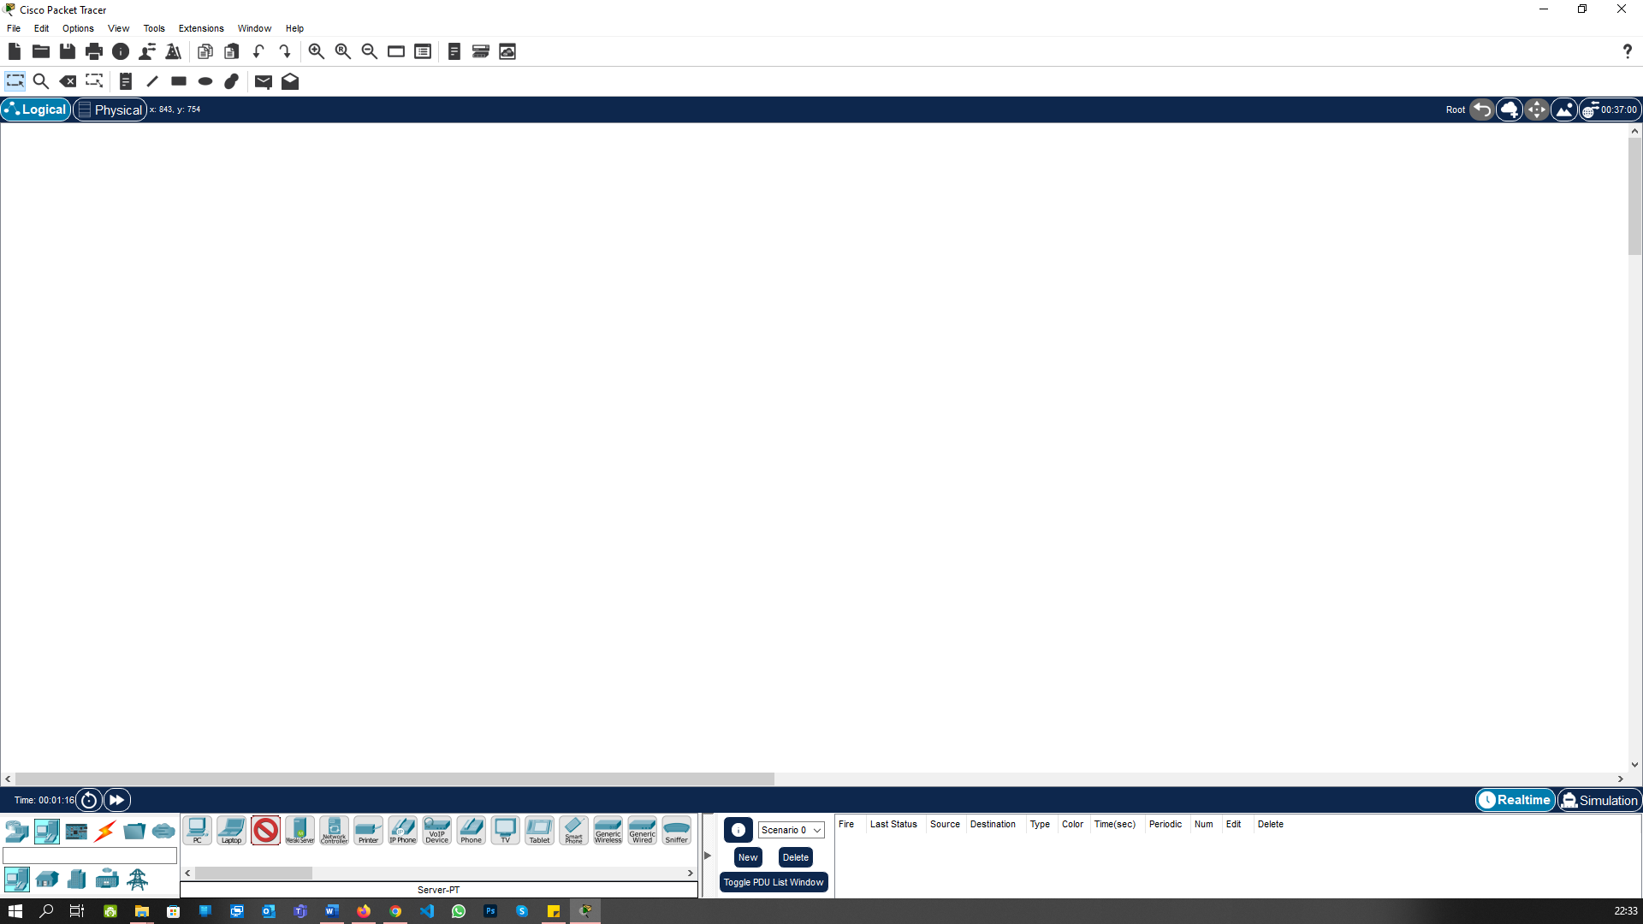

Go to the Bottom Bar “End Devices” and create the Server:

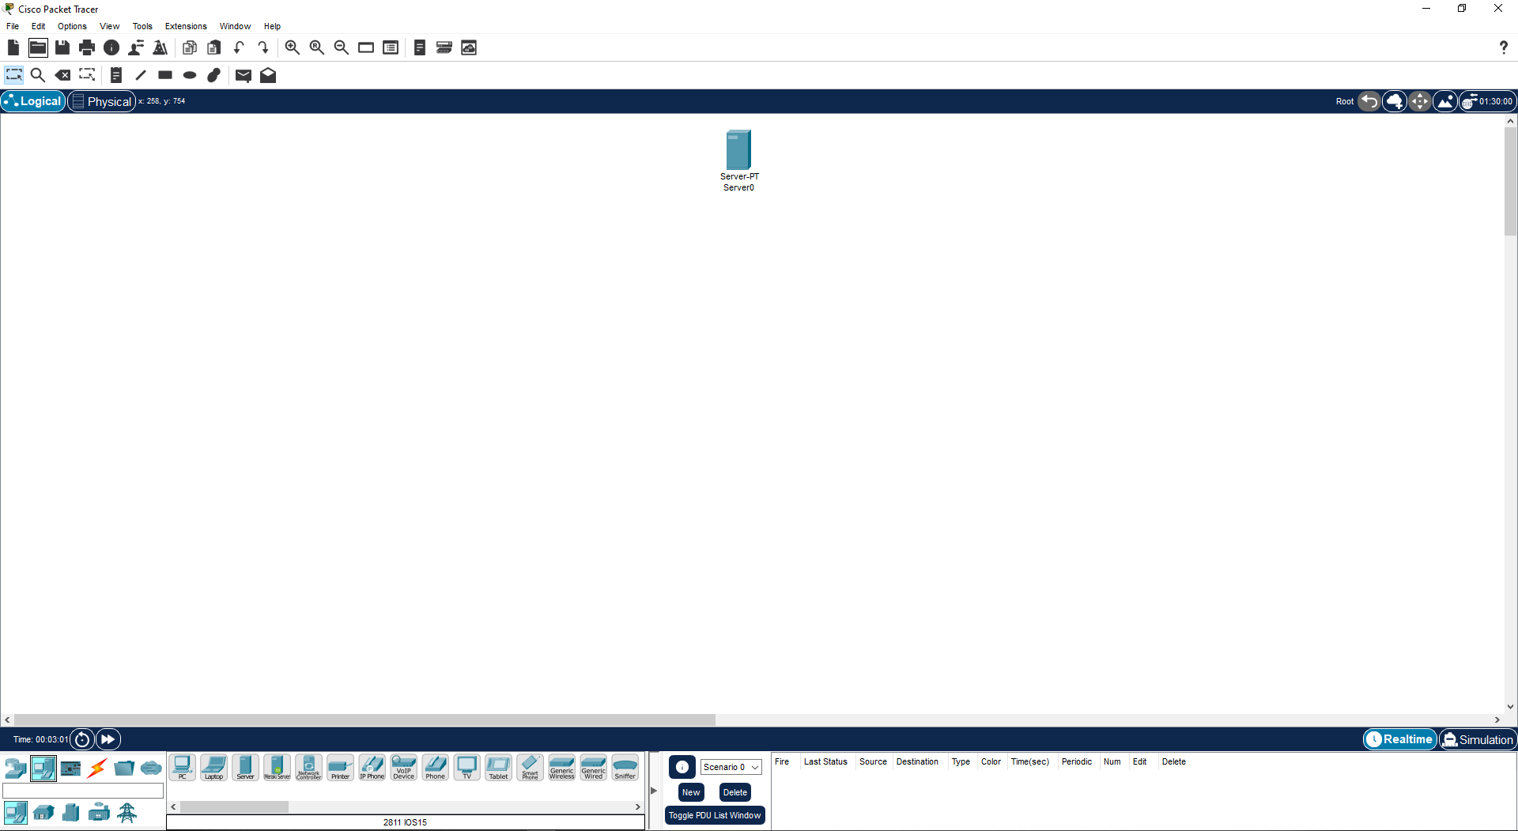

Go to network Devices and Select the Router 2811:

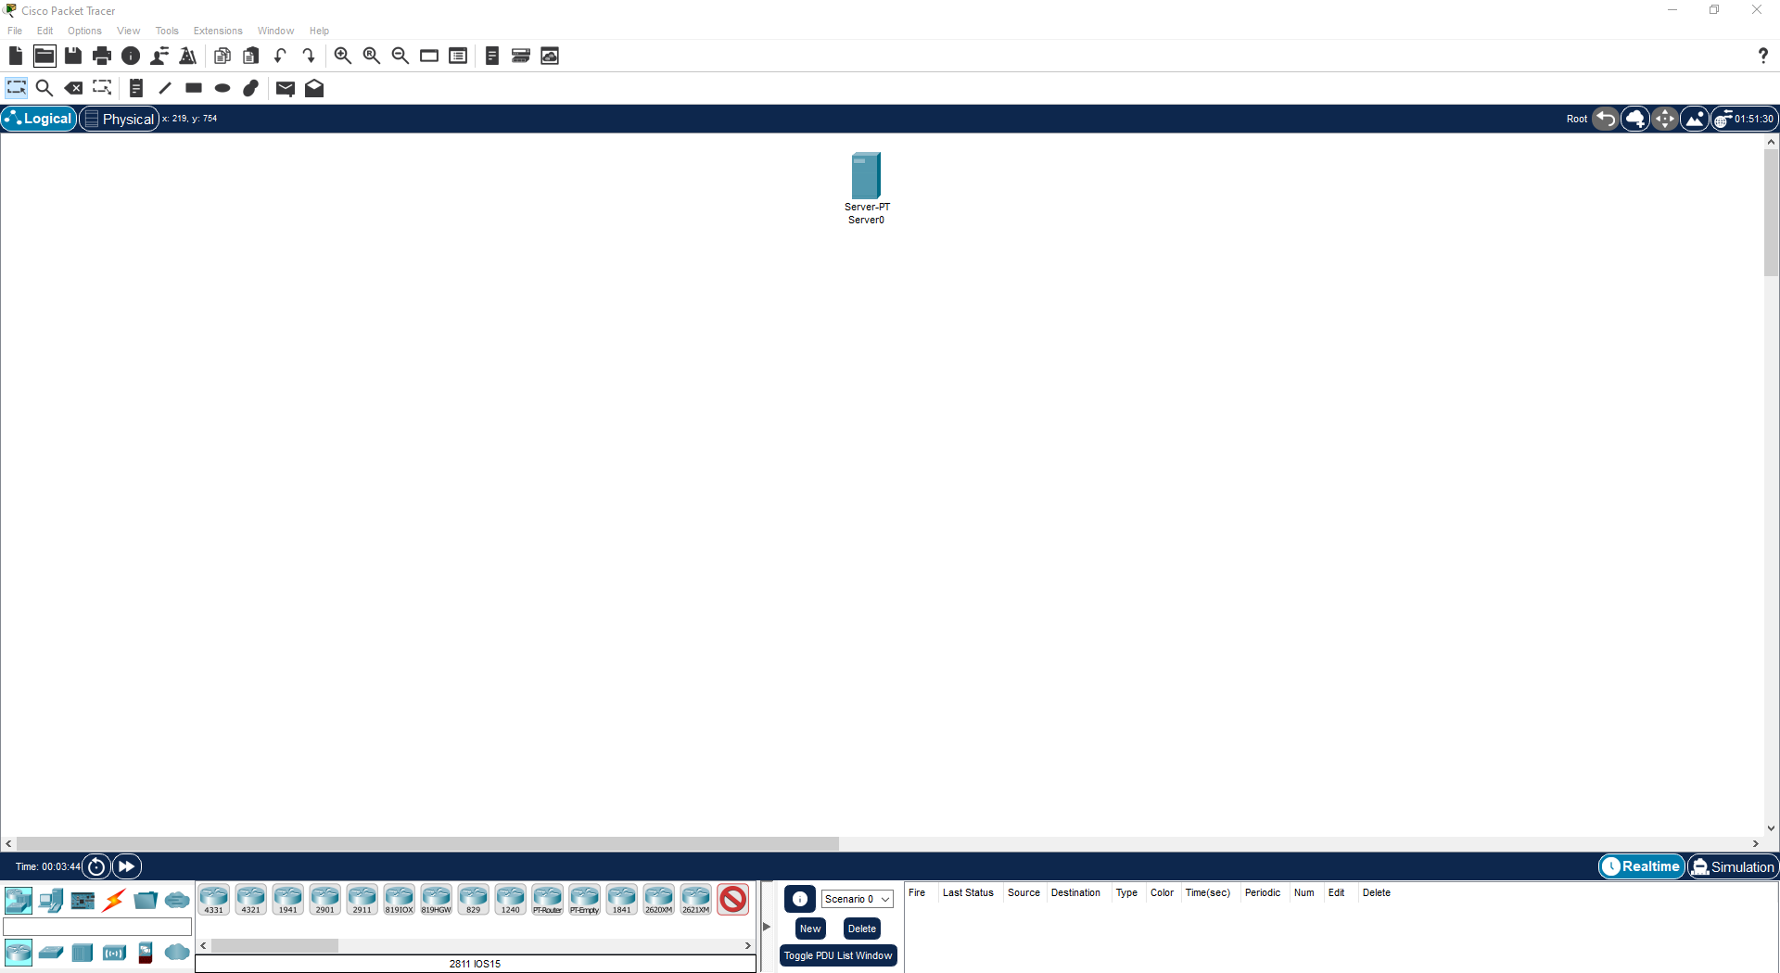

Now Create the Router 2811:

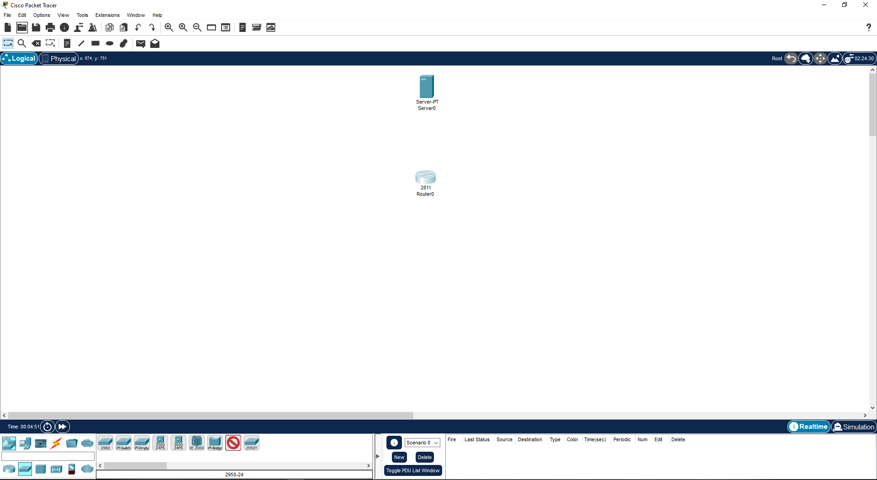

Select the Switch 2950-24 and create it:

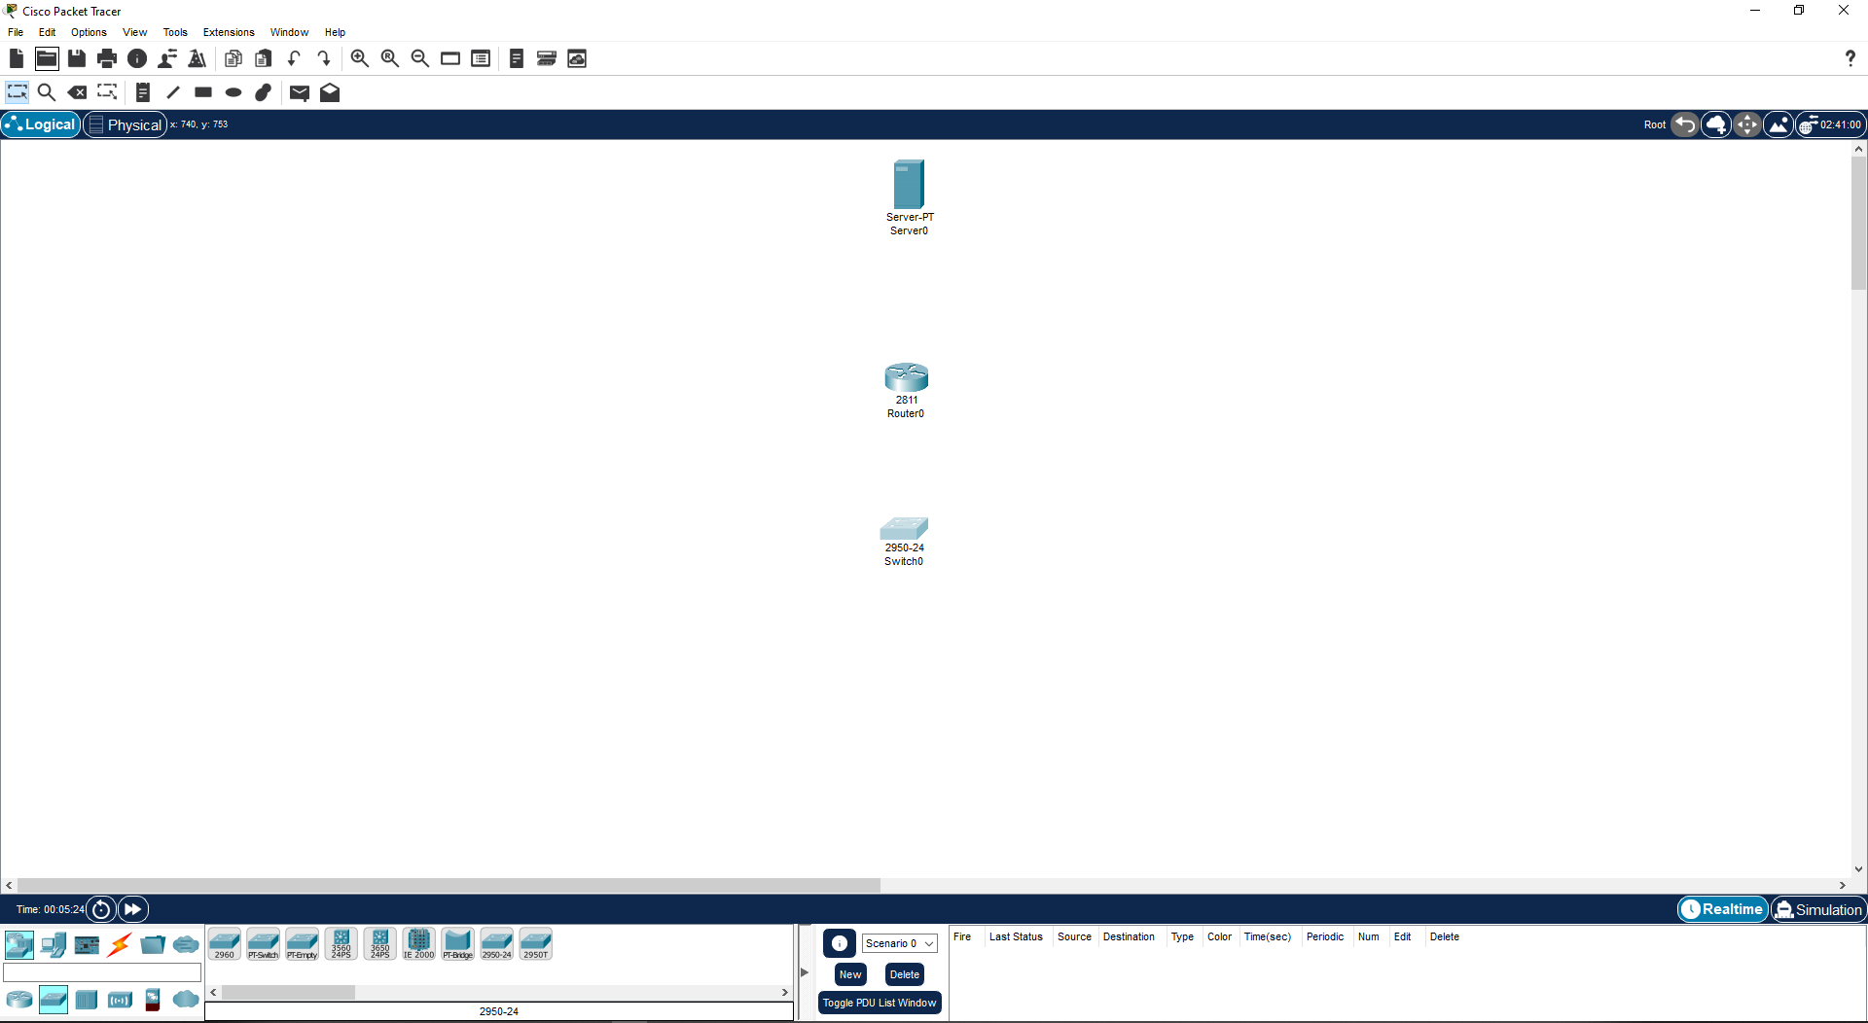

Again select the end devices and Select the Laptop:

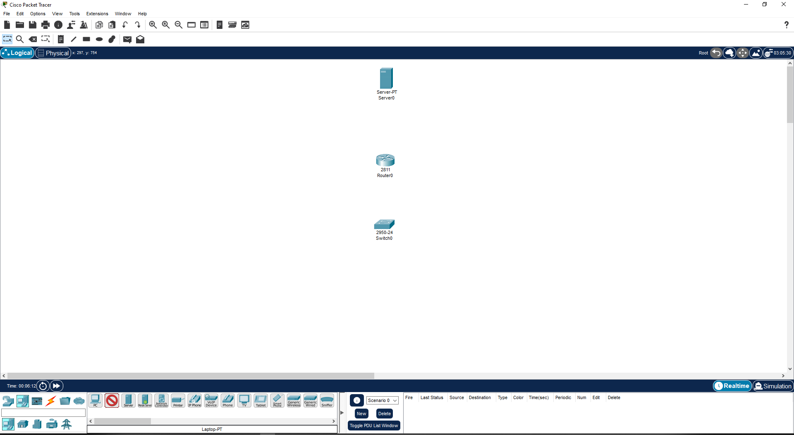

Create the 2 laptop in it:

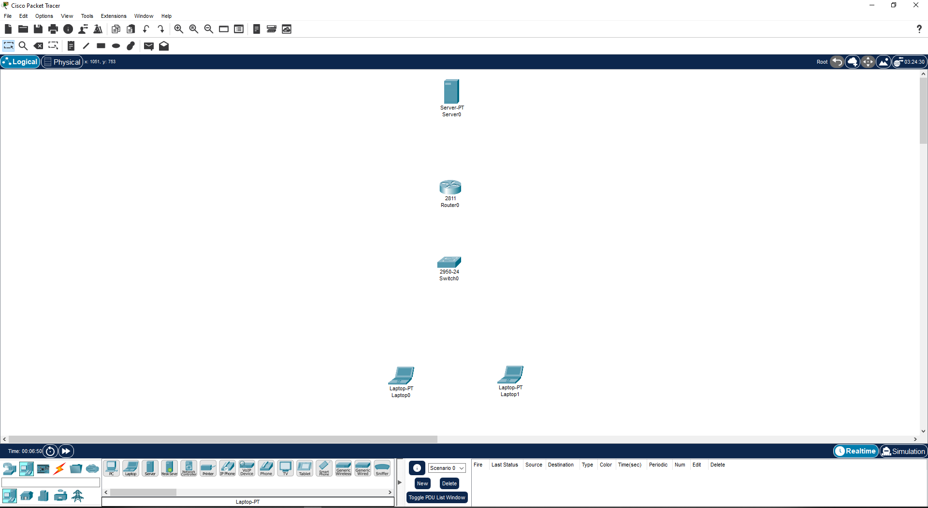

Select Connections from bottom bar and Do the Connection of all Devices using automatic wire type:

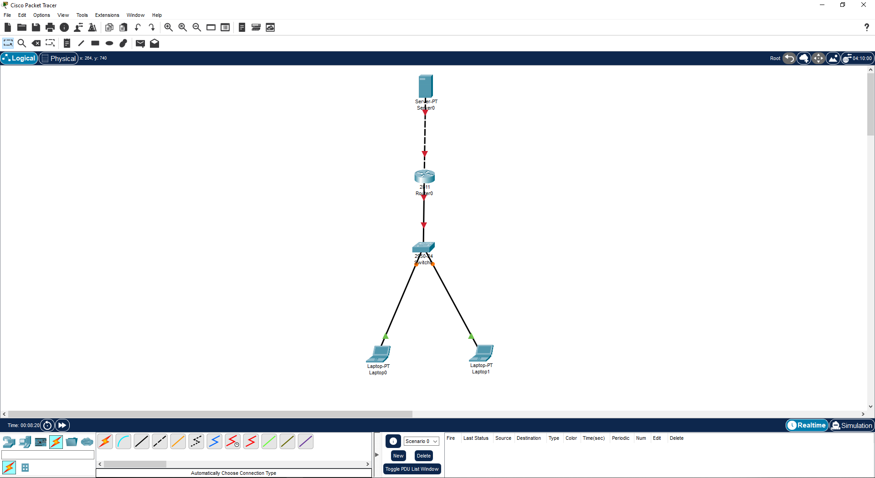

Open the router FastEthernet0/0:

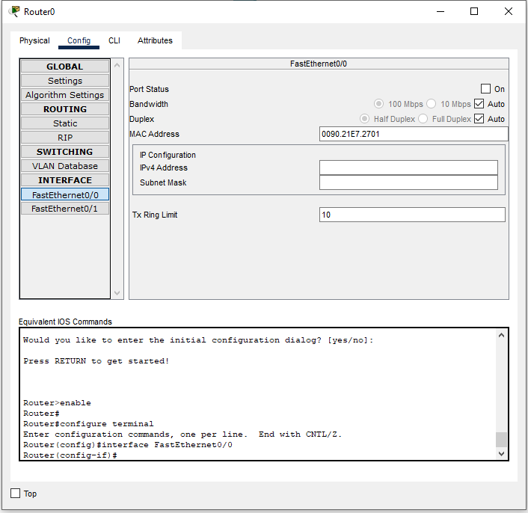

Assign the IP address for the port which is connected to Switch:

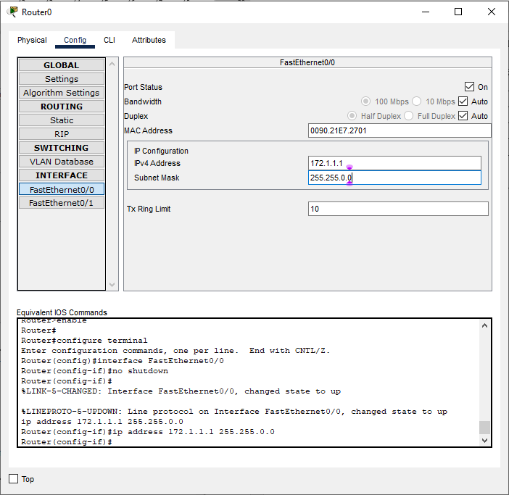

Assign the IP address for the FastEthernet0/1 which is connected to server:

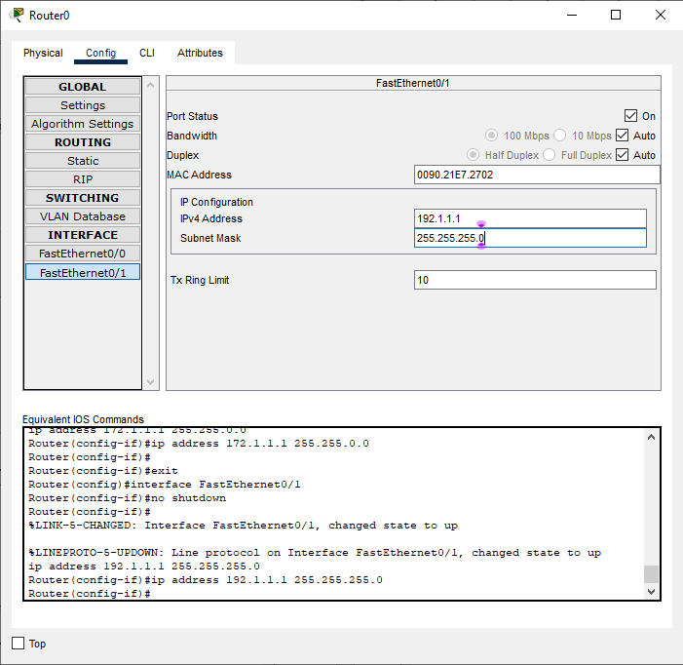

Open the server Config and Change the Display name to FTP Server:

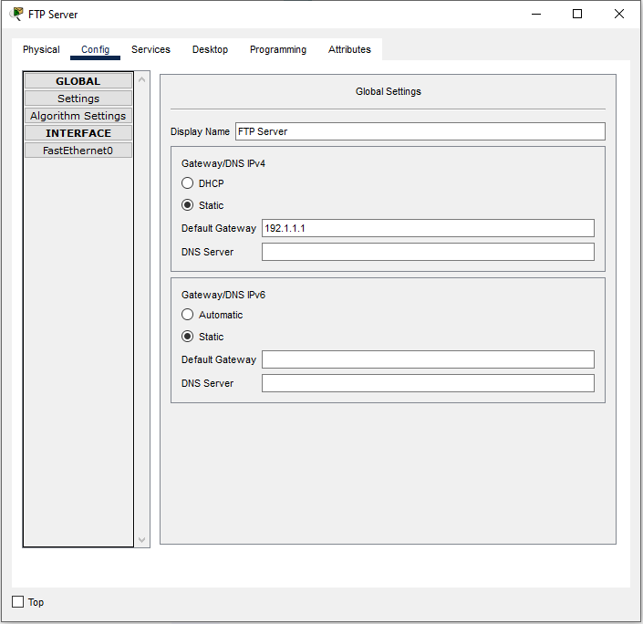

Open the router FastEthernet0 and Assign the IP Address to it:

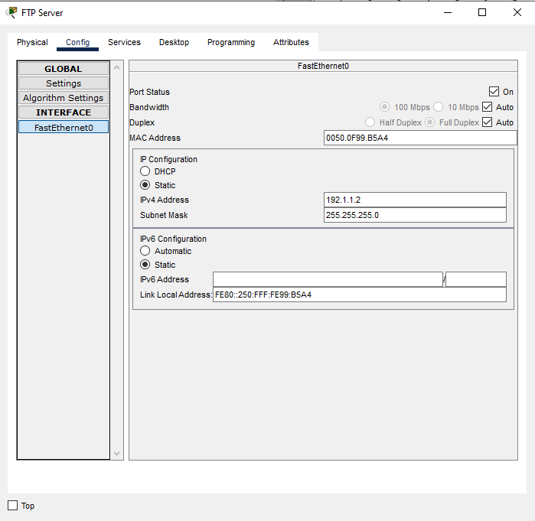

Go to Services select FTP and Add a new User with your name and all permission: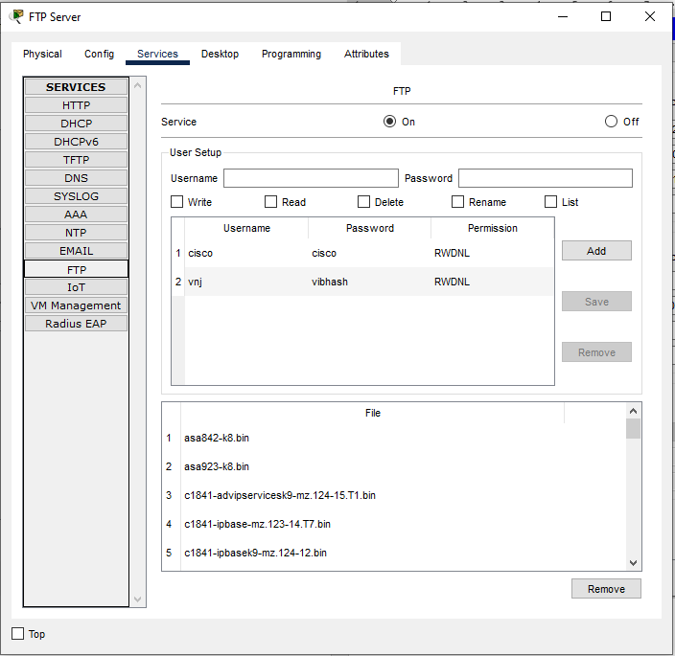

Open the Laptop0 and Assign the IP Address to it and Give the Default gateway which IP is assigned to the Router:  
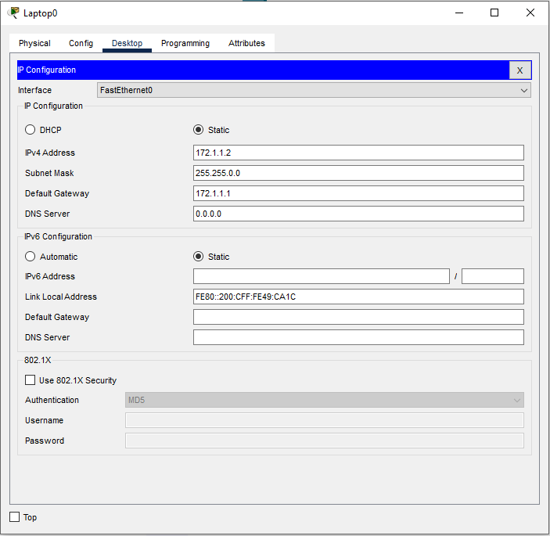

Open the Laptop1 and Assign the IP Address to it and Give the Default gateway which IP is assigned to the Router:

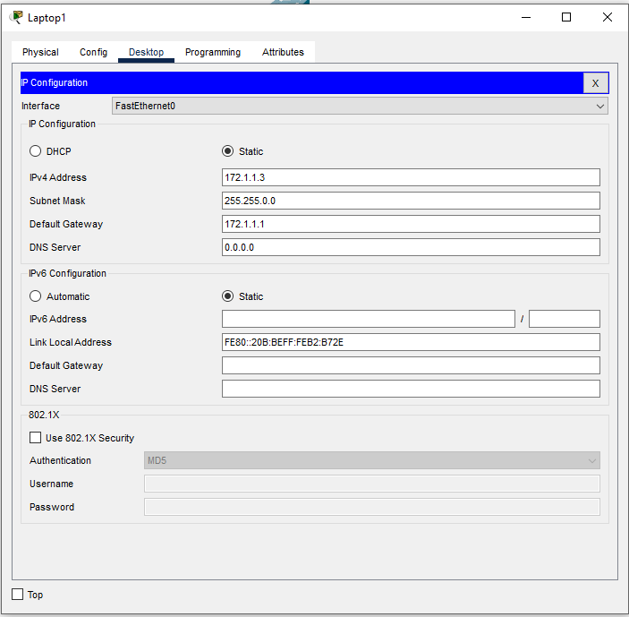

Now our Connection is Completed:

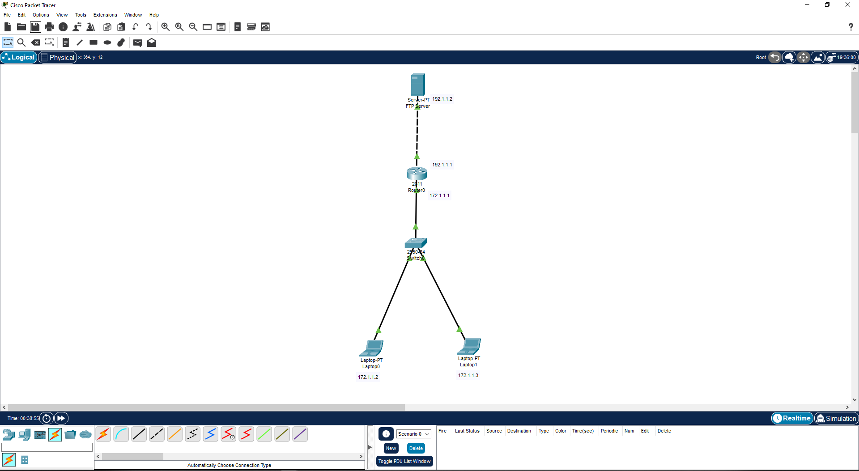

Now Open the Laptop0’s Test Editor and create a new file and give the Name: I have named it as **FTPTest.txt**

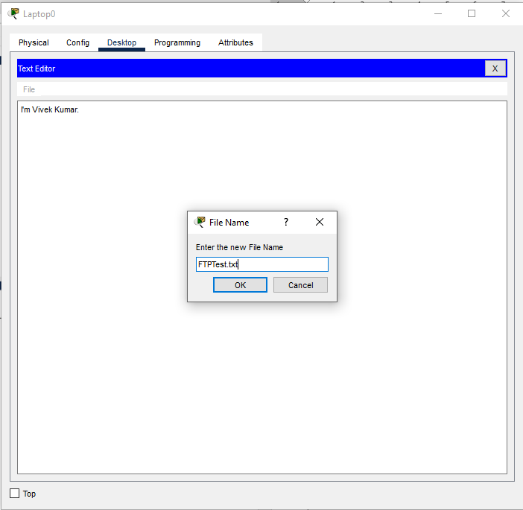

Check your file by opening TFTP Server in the Laptop0:

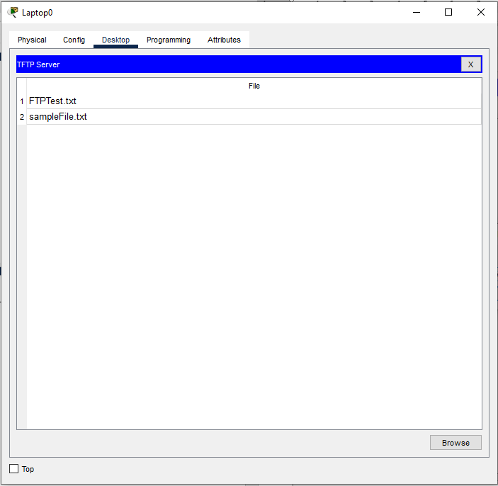

Open the Terminal of laptop0:

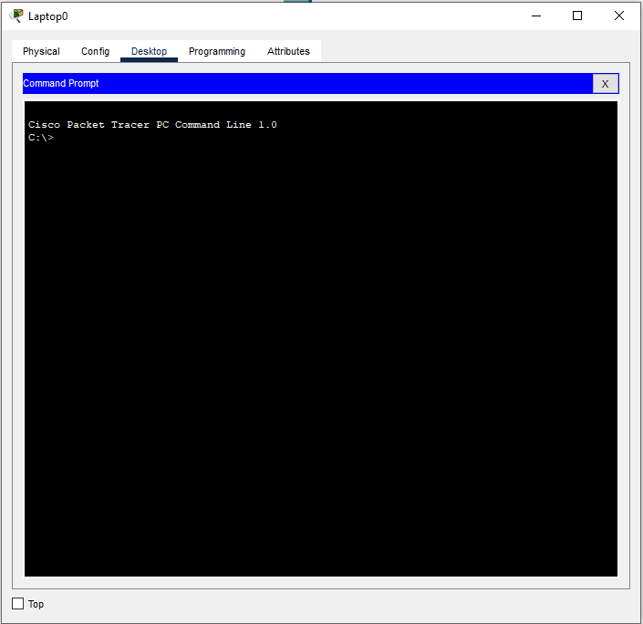

Run the ping Command with the Server IP Address to Check the Connection with The Server:

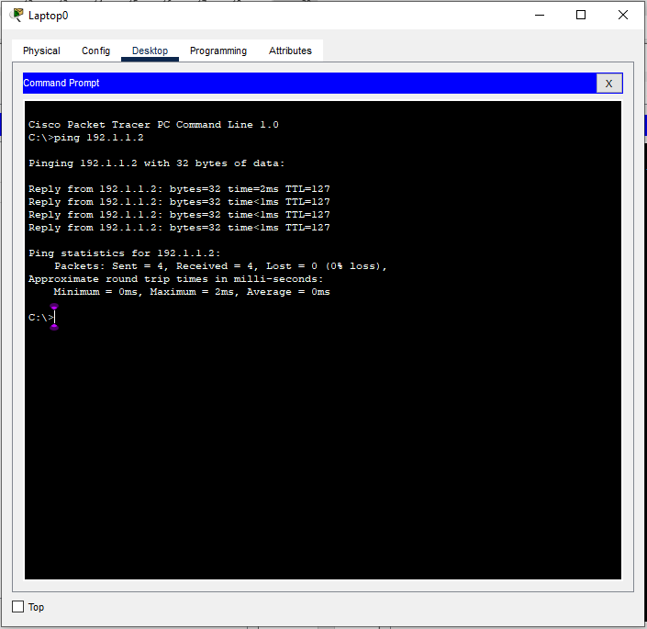

Now Run the FTP command with Server IP Address to login the Server in our Laptop0 and give the Username and Password of the user which we have created in the Server and Press Enter:

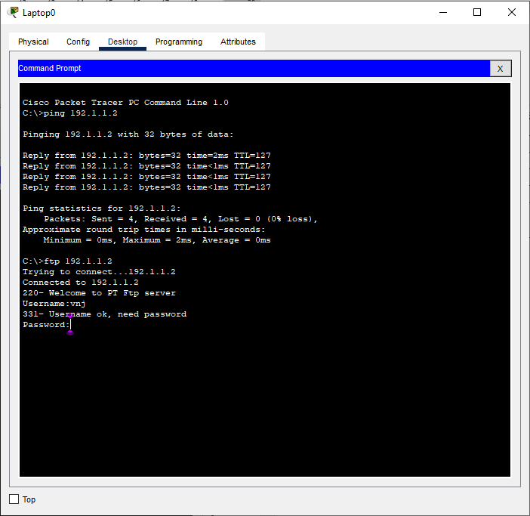

Now we have logged in the server:

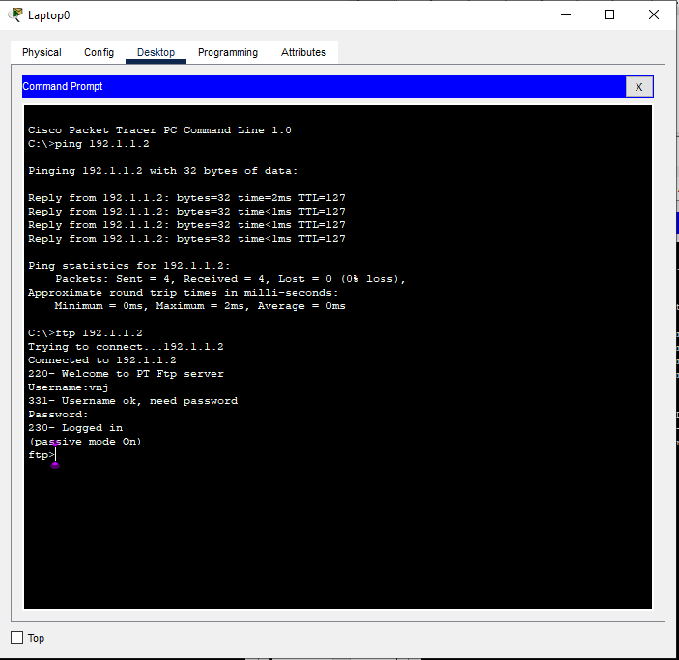

Run the DIR command to check the Files and Directories available in our server:

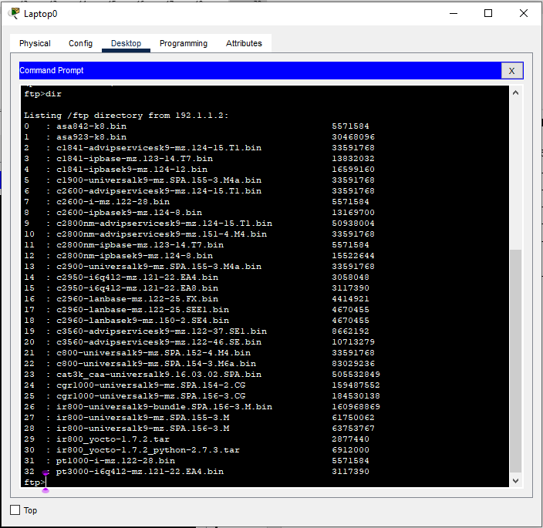

Using put command along with file name we will upload the created file in to the server:

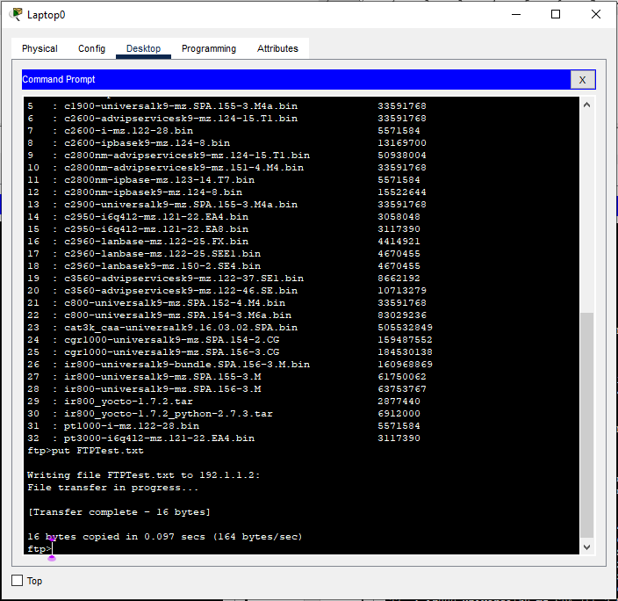

Now run the DIR command to check whether the file is uploaded to our server or not and our file is uploaded successfully:

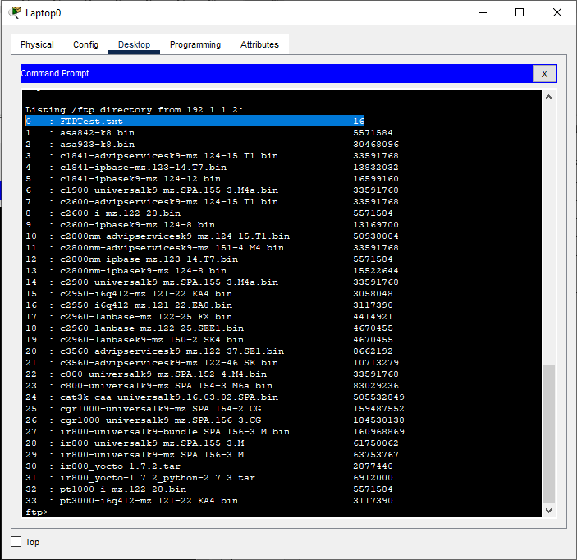

Now open the Laptop1 TFTP Server to check the Available files in the Laptop1:

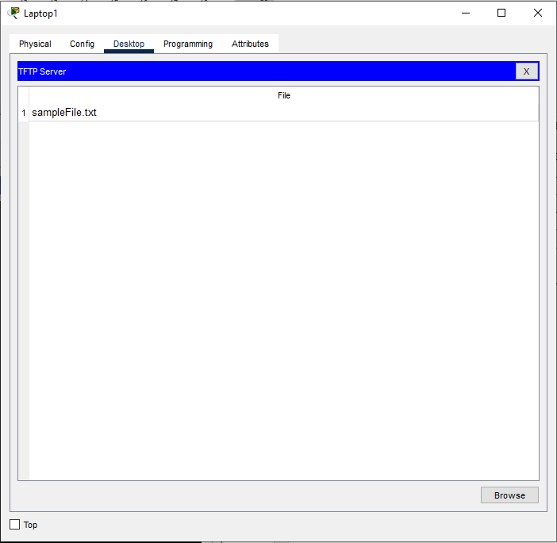

Open the Command Prompt in Laptop1:

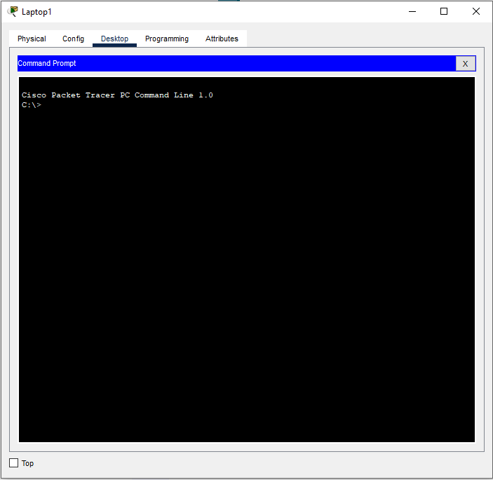

Run the Ping command along with the server IP Address to check the connectivity of the server with Laptop1:

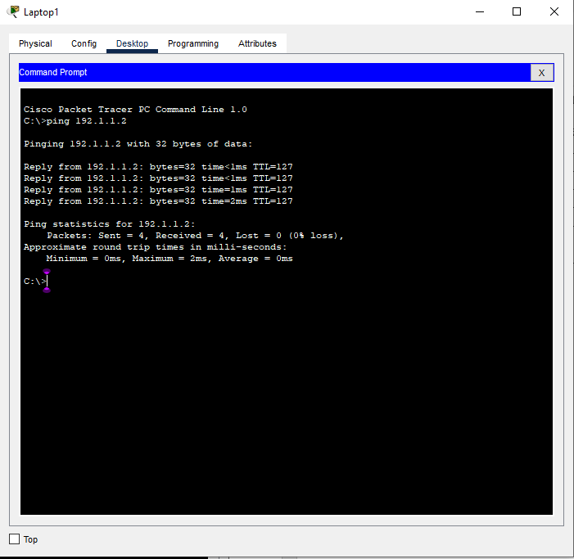

Now Run the FTP command along with The server IP Address to login the FTP Server, and Type the username and Password which we have created in the Server and press Enter to logging:

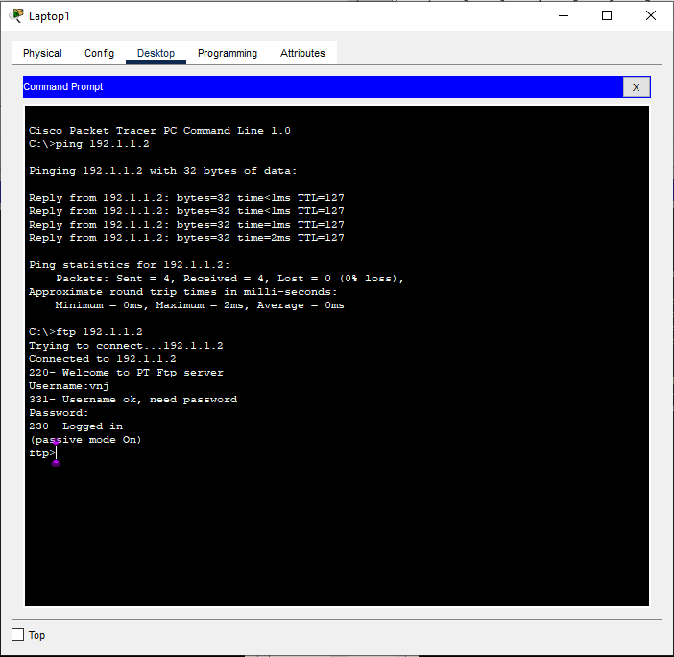

Now run the GET command along with the Specific file name which we want to download in the Laptop1:

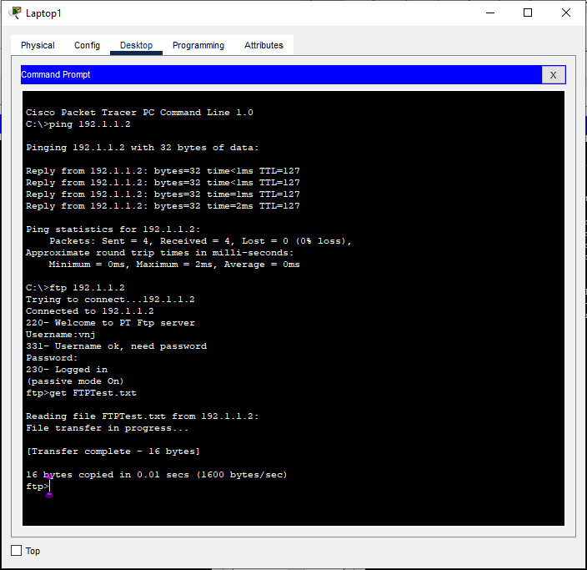

Now Check the TFTP Server of Laptop1 and there Downloaded file is Present:

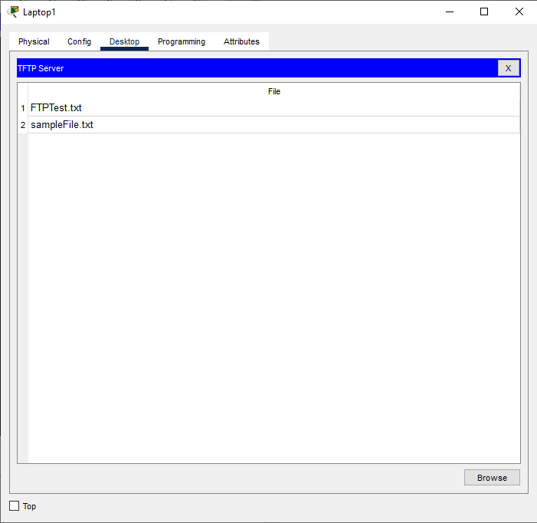

**Learning outcomes (What I have learnt):**

**1.** Learnthow to create the FTP Server connection.

**2.** Learnt how to Upload the File to server and how to download with the another system.

**Evaluation Grid (To be created as per the SOP and Assessment guidelines by the faculty):**

|  |  |  |  |
| --- | --- | --- | --- |
| Sr. No. | Parameters | Marks Obtained | Maximum Marks |
| 1. |  |  |  |
| 2. |  |  |  |
| 3. |  |  |  |
|  |  |  |  |